Name: ERIC AGYEMANG

**REPORT**

|  |  |
| --- | --- |
|  | **Logsize** |
| **Logtotal** | -0.09447  0.3869  86 |

|  |  |
| --- | --- |
|  | **Avesize** |
| **Total** | -0.14489  0.1832  86 |

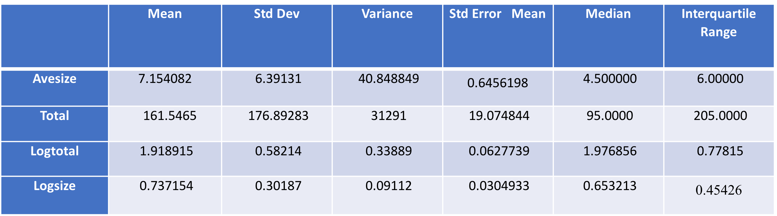

Table 1.0 Summary Statistics

Table 1.1

Table 1.2

Correlation Coefficient

**Table 1.0** The results from the summary statistics table shows the difference between various statistical measure between variables without subfamily. The total clearly depicts larger values whereas the log size depicts comparably smaller values. **Table 1.1, Table 1.2** The correlation coefficient measures the strength and direction of linear relationship between the two variables. Total and Avesise shows weak downhill(negative) relationship whiles Logtotal and Logsize shows even more weaker relationship with their values falling between (-0.01 to - 0.5)

**Scale Analysis**

According to the *figure 1.0 – 1.4*below**,** the data set derived on the natural versus logarithmic scales with respect to Average and Total variables has **skewness property**. The Avesize(*fig.1.0)* is **positively skew** with most of the sample values are clustered at a particular side of the histogram. The Total (*fig1.1)* is **positively skewed** with most of the sample values clustered at a particular of the histogram. The logarithmic scales namely Logsize, Logtotal *(fig.1.3,1.4 respectively)* is the closest to producing symmetrical distribution (no skew). Both scales shapes approximately the same on both sides.

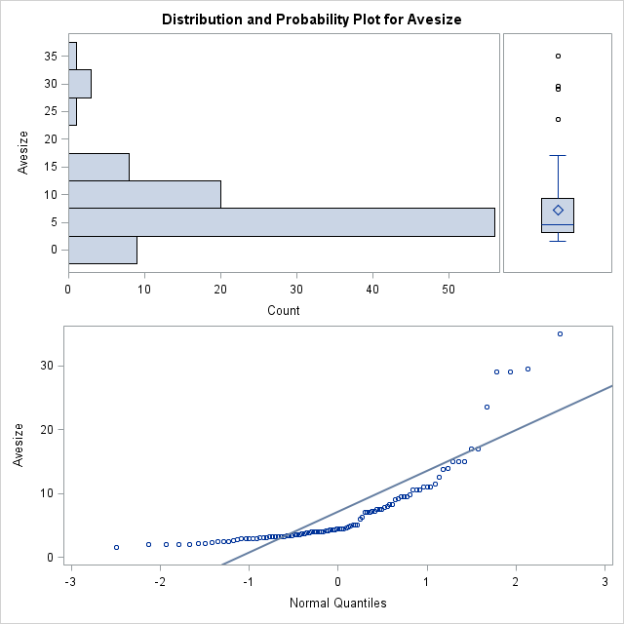

*Figure 1.0*

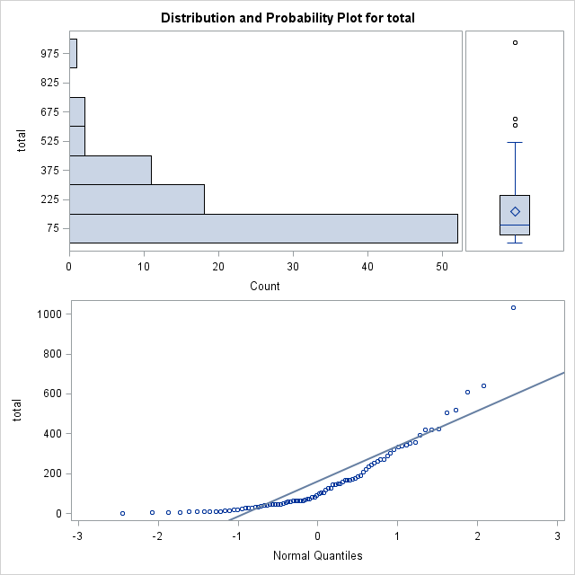

*Figure 1.1*

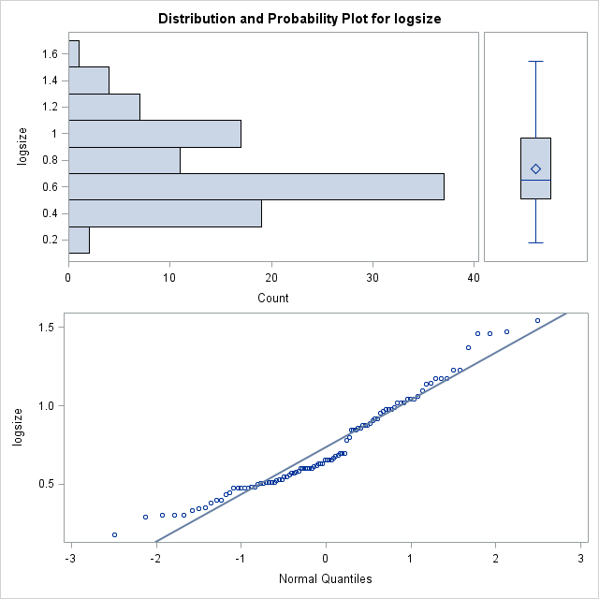

*Figure1.3*

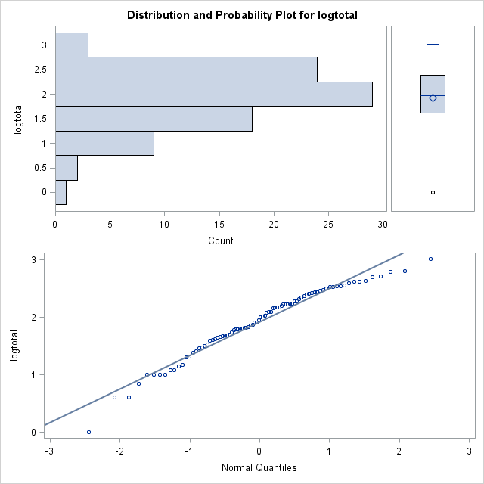

*Figure 1.4*

**Geographic range Vs Average body size**

From the diagram below, plot 1.0 with total on y axis and avesize on x axis has various points on this plot its clustered together and assumes a couple of outliers in it distribution. Also plot 1.1 with logtotal on the y axis and logsize on the x axis has more spread out distribution on the plot. This two result demonstrated different pattern of relation in their correlation.

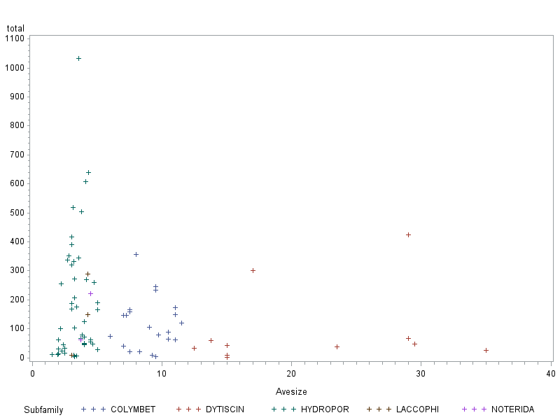

Plot 1.0

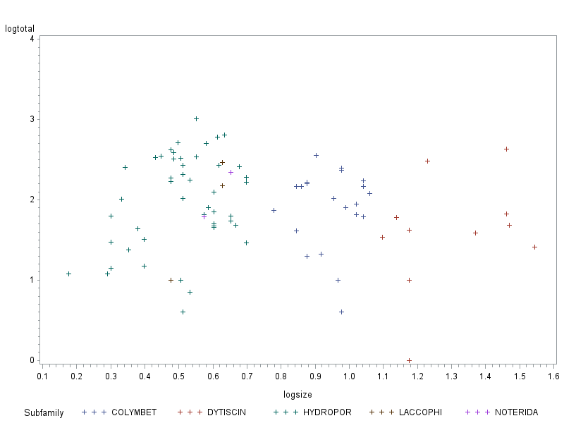Plot 1.1

|  |  |  |  |  |  |  |
| --- | --- | --- | --- | --- | --- | --- |
|  | Mean | Std Dev | Variance | Std Error Mean | Median | Interquartile Range |
| Logsize | 1.30033539 | 0.16263253 | 0.02644934 | 0.04903555 | 1.230449 | 0.28631 |
| Logtotal | 1.59574444 | 0.69844555 | 0.48782619 | 0.21058926 | 1.623249 | 0.41110 |

Table 2.0: Summary Statistics for DYTISCIN

|  |  |  |  |  |  |  |
| --- | --- | --- | --- | --- | --- | --- |
|  | Mean | Std Dev | Variance | Std Error Mean | Median | Interquartile Range |
| Logsize | 0.95313311 | 0.10413395 | 0.01084 | 0.01967947 | 0.960192 | 0.14613 |
| Logtotal | 1.892016 | 0.48727753 | 0.23743939 | 0.10633268 | 2.021189 | 0.41607 |

|  |  |  |  |  |  |  |
| --- | --- | --- | --- | --- | --- | --- |
|  | Mean | Std Dev | Variance | Std Error Mean | Median | Interquartile Range |
| Logsize | 0.52386236 | 0.13069117 | 0.01708018 | 0.01778481 | 0.528262 | 0.12494 |
| Logtotal | 1.99926422 | 0.58262119 | 0.33944745 | 0.0832316 | 2.096910 | 0.85194 |

Table 2.1: Summary Statistics for COLYMBET

Table 2.3: Summary Statistics for HYDROPOR

|  |  |  |  |  |  |  |
| --- | --- | --- | --- | --- | --- | --- |
|  | Mean | Std Dev | Variance | Std Error Mean | Median | Interquartile Range |
| Logsize | 0.57796637 | 0.08733 | 0.0076273 | 0.05042256 | 0.628389 | 0.15127 |
| Logtotal | 1.87949642 | 0.77500216 | 0.60062835 | 0.44744771 | 2.176091 | 1.46240 |

Table 2.4: Summary Statistics for LACCOPHI

|  |  |  |  |  |  |  |
| --- | --- | --- | --- | --- | --- | --- |
|  | Mean | Std Dev | Variance | Std Error Mean | Median | Interquartile Range |
| Logsize | 0.61362189 | 0.0559896 | 0.00313483 | 0.03959062 | 0.613622 | 0.07918 |
| Logtotal | 2.06937233 | 0.39170978 | 0.15343655 | 0.27698064 | 2.069372 | 0.55396 |

Table 2.5: Summary Statistics for NOTREDIA

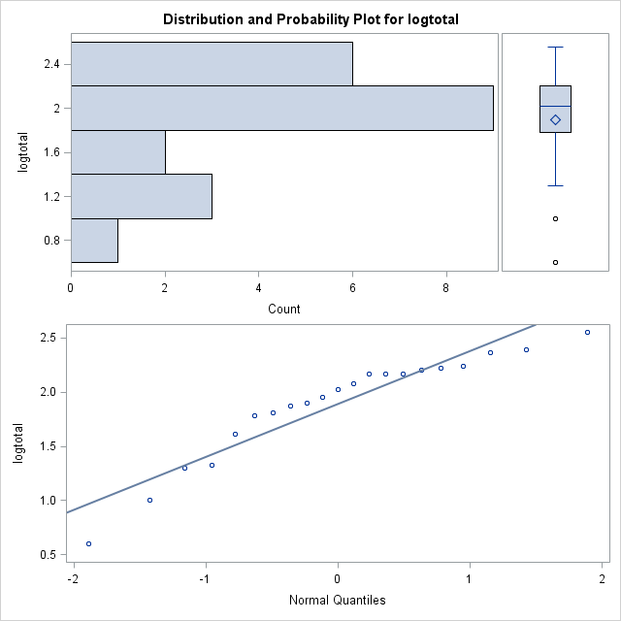

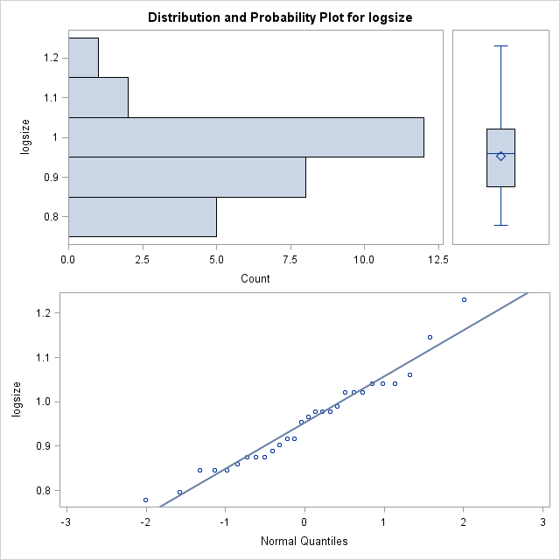

COLYMBET

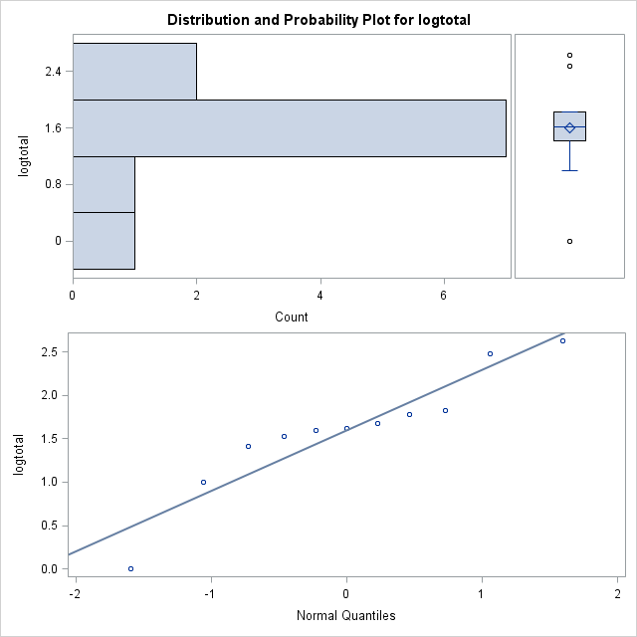

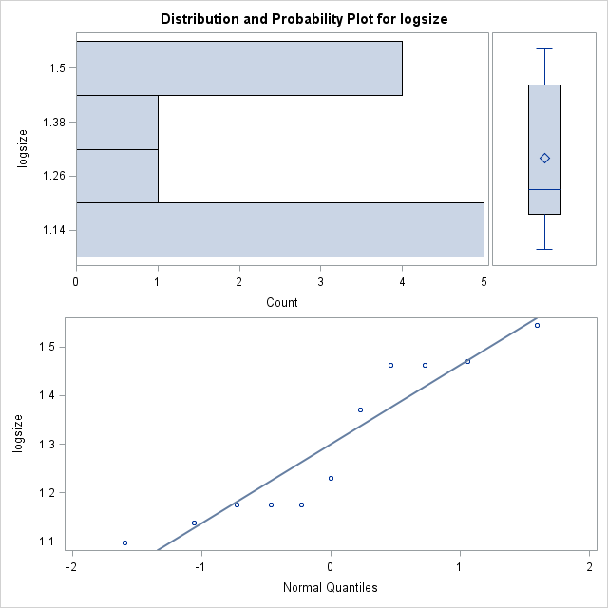

DYTISCIN

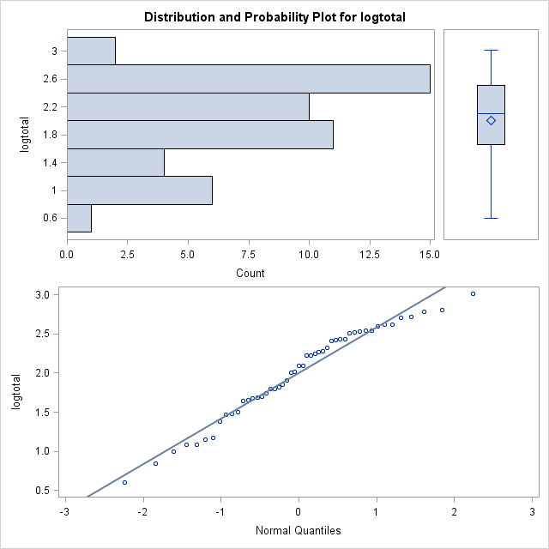

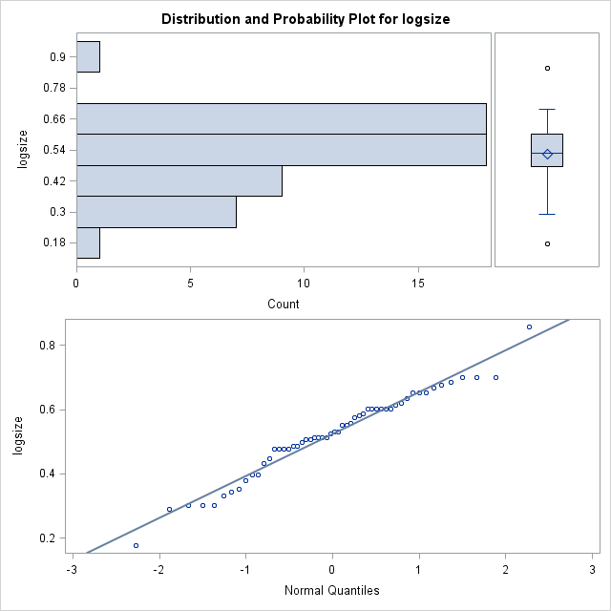

HYDROPRO

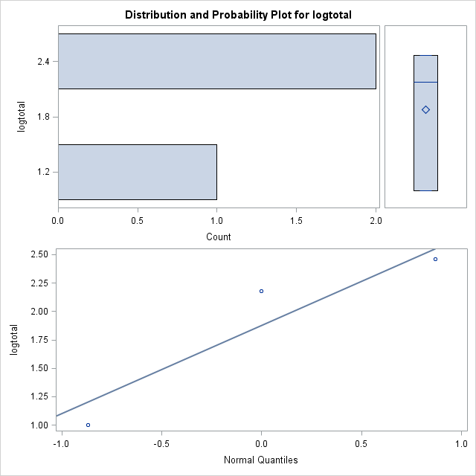

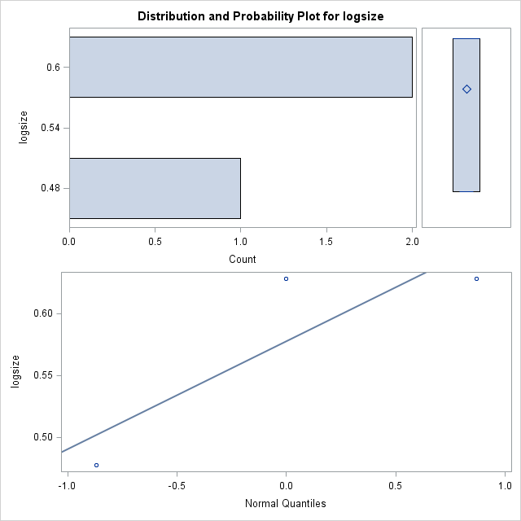

LACCOPHI

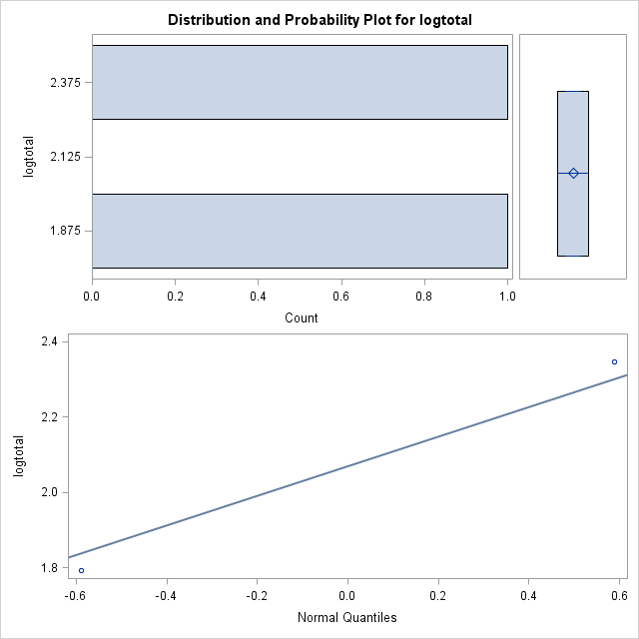

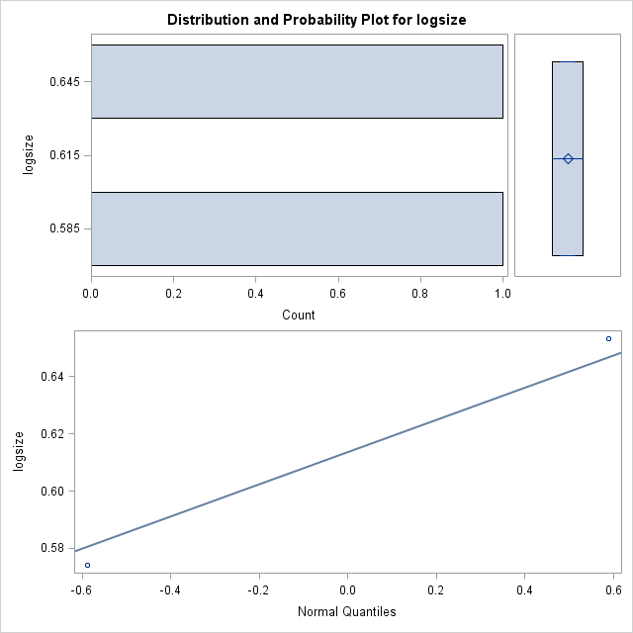

NOTREDIA